Git Repository Setup (Mac)

1. Set up a GitHub account, and once you do send me which email you used to make the account so I can add you to the collaborators list. The website is located at github.com
2. Once you are added to the collaborators list it is time to set up your file directory.
3. Open a Terminal window on you Mac. To do this open up your launch pad and start typing “Terminal” and it should pop up. It should look something similar to this:   
     
   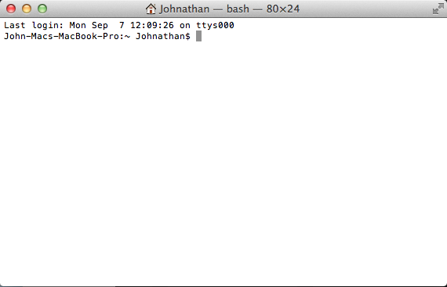
4. Navigate to your desired working directory, so if you would like the folder to be on your desktop in a folder named ‘SeniorProjects’, type in the following:  
     
   cd Desktop/Senior\ Projects/  
     
   After you type this in, your terminal should look something like this:   
     
   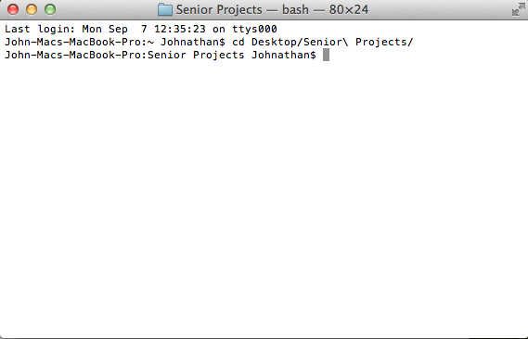
5. Now that you are here, you need to type the following command to copy the git repository to your personal file directory:  
     
   git clone <https://github.com/JohnThom212/INFERNO.git>  
     
   Now your terminal window should look like this, once the command finishes:  
     
   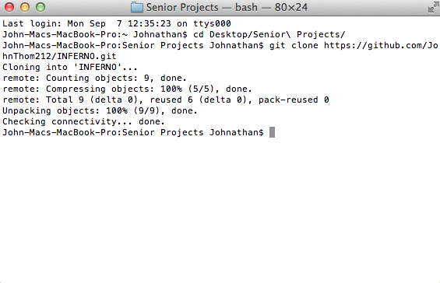
6. Now that we have the directory set up you should be able to cd into the directory, and then look at what is already in the directory by typing in:  
     
   cd INFERNO  
   ls

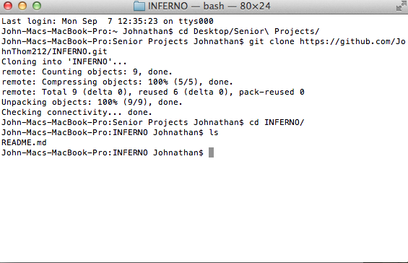

1. So that I can ensure you have gained access to the repository you should edit the README.md file and insert your contact information, you can open this file in any text editor. If you have trouble with this contact me and I can help you.
2. Now on to adding, commiting, and pushing. Once you have edited the file you need to add it, commit it, and push it so that everyone else can see it. Once you have edited the file if you type in the command:  
     
   git status  
     
   You will see this:  
     
   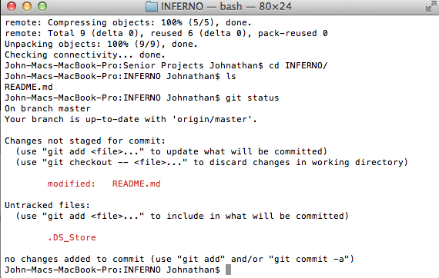  
   This shows that the README.md file has been modified, now you need to add the file and commit it. To add the file type:  
     
   git add .  
     
   The ‘.’ At the end means you are adding all altered files so that later on you do not have to add every altered file individually but you could also type:  
     
   git add README.md  
     
   This would add only the one file that you altered. After you add the file your terminal window should not say anything. Next you need to commit files that you have added. To do this type the following:  
     
   git commit –m “Edited README”  
     
   The –m flag allows you to add a commit message explaining what you did, and you should always provide a commit message to say what you have done. Once you have committed your terminal window will look like this:  
     
   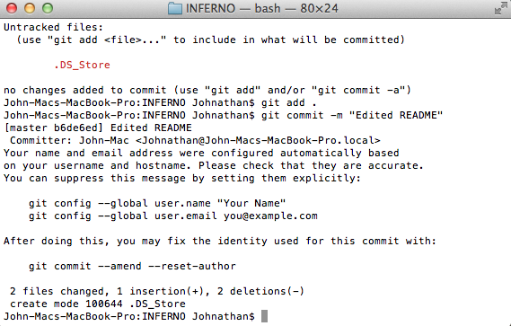  
   Now the last thing to do is push the files back to the repository because everything you have done thus far has been on you local machine, to do this type in the following:  
     
   git push origin master  
     
   now your terminal should look like this:  
     
   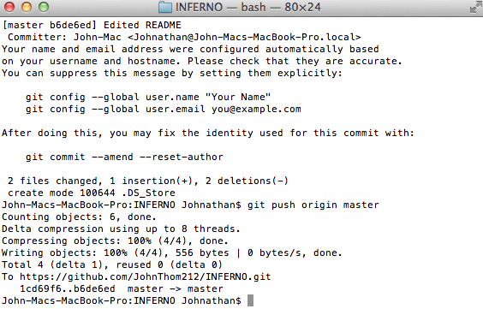
3. Now you are done, however everytime you enter this folder to work on things you need to pull everything down from the repository so that you make sure you are always working on the most current documents. This command is simply:  
     
   git pull  
     
   This should look like this in terminal:  
   